AGB Email Signatures – Event Promotions
Select from event promo banners below to add to your signature. You can replace the sample banner with the appropriate version for your audience.

Banners are hyperlinked, but be sure to double check that the link is working in your signature.

SAMPLE Banner placement:
________________________
JOHN SMITH
TITLE
AGB | Govern with Confidence
202.296.8400 (main) | 000.000.0000 (direct)
AGB.org
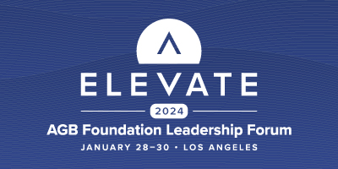

BANNER OPTIONS (Please select ONE and be sure the banner hyperlink works once copied and pasted into your email signature.)

